MAD SS10
MAD SS10: Rummaging Through the Garbage of Human History
Assigned: Wednesday, November 15 - Due: Monday, November 21
Name: _______________________________________
(staple to any loose papers, please)

What we’ll learn:
- The dangers of the Cold War brought about by tensions after WW2 between the US, USSR and their allies
- The significance of events, people and places as relates to the situation
- Critical thinking skills, where we need to transform a global conflict into a relatable situation

Description of the Assignment:
- This is a group presentation, but each member of the group is responsible for their own part and is graded separately on their part in the presentation.
- You are all aliens who have come to Earth to study archeology and specialize in the theory that 1983 could have been an early end for the human race, rather when it happened in 2025.
- With your team, you are gathering information from old newspapers, and something that was once called ‘The Internet’ for information on this time period. You luck upon an old ‘article’ from an online magazine called ‘Vox’, which had its information stored on a diamond disk
- Now that you have information from these long-dead human writers, you three can create a common presentation for your peers. You are playing the part of a panel of three alien experts for a group of other alien journalists in the audience. Each of you has a point of view to present on:
- ‘Vivian’ will be presenting why this is a story of a hero
- ‘Mario’ will be presenting why this is an example of why computers cannot be trusted over human experience
- ‘Amelia’ will be presenting on how the US could have caused a war through all their efforts to make the USSR on alert constantly and be paranoid
- The presentation can only have one word or picture per slide and you can only have two slides each. The presentation should have three points to make about the point you are covering. The audience is also allowed to ask a few questions of the experts after the presentation

39 years ago today, one man saved us from world-ending nuclear war
On September 26, 1983, Stanislav Petrov saved the world.
By Dylan Matthewsdylan@vox.com Updated Sep 26, 2022, 11:07am EDT

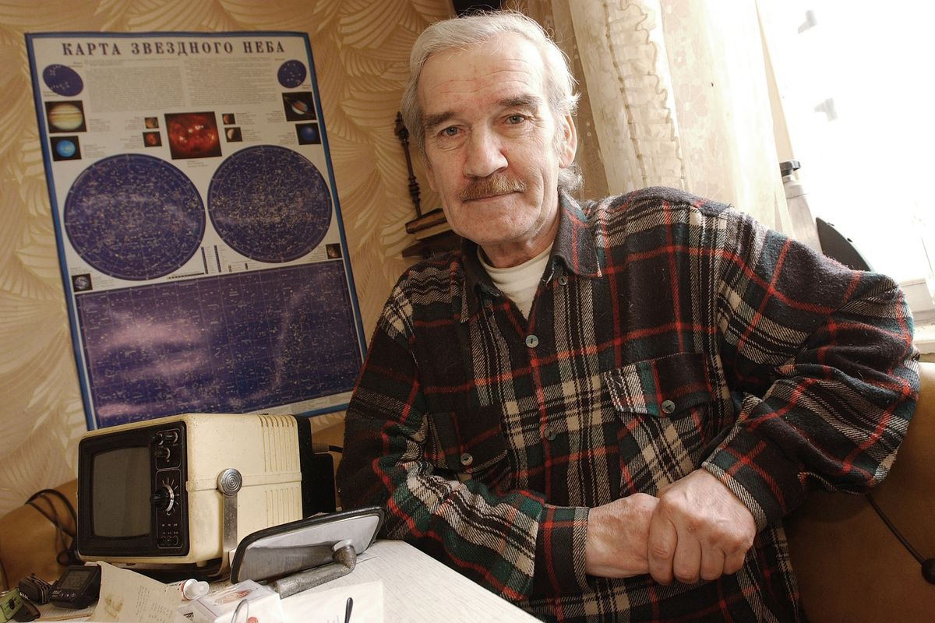
Former Soviet Col. Stanislav Petrov, the man who prevented a nuclear war, pictured in his home in 2004. Scott Peterson/Getty Images
Finding the best ways to do good.
Editor’s note, September 26, 2022: This article has been updated to reflect recent nuclear tensions between the US and Russia.
On September 26, 1983, the planet came terrifyingly close to a nuclear holocaust.
The Soviet Union’s missile attack early warning system displayed, in large red letters, the word “LAUNCH”; a computer screen stated to the officer on duty, Soviet Lt. Col. Stanislav Petrov, that it could say with “high reliability” that an American intercontinental ballistic missile (ICBM) had been launched and was headed toward the Soviet Union. First, it was just one missile, but then another, and another, until the system reported that a total of five Minuteman ICBMs had been launched.
“Petrov had to make a decision: Would he report an incoming American strike?” my then-colleague Max Fisher explained. “If he did, Soviet nuclear doctrine called for a full nuclear retaliation; there would be no time to double-check the warning system, much less seek negotiations with the US.”
Reporting it would have made a certain degree of sense. The Reagan administration had a far more hardline stance against the Soviets than the Carter, Ford, or Nixon administrations before it. Months earlier President Reagan had announced the Strategic Defense Initiative (mockingly dubbed “Star Wars,” a plan to shoot down ballistic missiles before they reached the US), and his administration was in the process of deploying Pershing II nuclear-armed missiles to West Germany and Great Britain, which were capable of striking the Soviet Union. There were reasons for Petrov to think Reagan’s brinkmanship had escalated to an actual nuclear exchange.
But Petrov did not report the incoming strike. He and others on his staff concluded that what they were seeing was a false alarm. And it was; the system mistook the sun’s reflection off clouds for a missile. Petrov prevented a nuclear war between the Soviets, who had 35,804 nuclear warheads in 1983, and the US, which had 23,305.
A 1979 report by Congress’s Office of Technology Assessment estimated that a full-scale Soviet assault on the US would kill 35 to 77 percent of the US population — or between 82 million and 180 million people in 1983. The inevitable US counterstrike would kill 20 to 40 percent of the Soviet population, or between 54 million and 108 million people. The combined death toll there (between 136 million and 288 million) swamps the death toll of any war, genocide, or other violent catastrophe in human history. Proportional to world population, it would be rivaled only by the An Lushan rebellion in eighth-century China and the Mongol conquests of the 13th century.
And it’s likely hundreds of millions more would have died once the conflict disrupted global temperatures and severely hampered agriculture. International Physicians for the Prevention of Nuclear War put the potential death toll from starvation at about 2 billion.
Petrov, almost single-handedly, prevented those deaths.
Preventing the deaths of hundreds of millions, if not billions, of people was a costly decision for Petrov. If he had been wrong, and he somehow survived the American nuclear strike, he likely would’ve been executed for treason. Even though he was right, he was, according to the Washington Post’s David Hoffman, “relentlessly interrogated afterward [and] never rewarded for his decision.”
After the Cold War, Petrov would receive a number of commendations for saving the world. He was honored at the United Nations, received the Dresden Peace Prize, and was profiled in the documentary The Man Who Saved the World. “I was just at the right place at the right time,” he told the filmmakers. He died in May 2017, at the age of 77. Two books about the Petrov incident and other nuclear close calls in 1983 (related to the NATO exercise Able Archer) came out in recent years: Taylor Downing’s 1983 and Marc Ambinder’s The Brink.

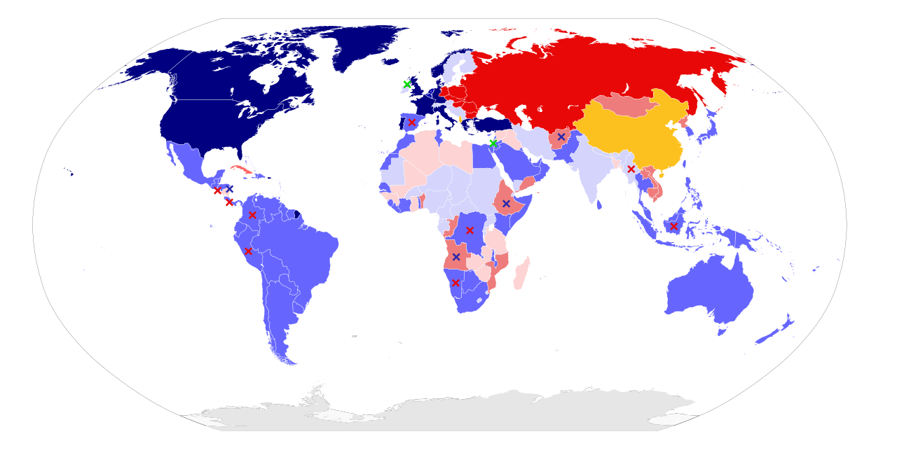Alliances in 1980: NATO and Western allies, Warsaw Pact and other Soviet allies, nonaligned states, China and Albania (communist countries not aligned with USSR), ××× armed resistance

10 | Exceeding | Proficient | Developing | Emerging
You can show why people, places, events and developments are significant | You’ve shown how this event had a significant chance of starting a world war in 1983 | You have been mostly clear about the reasons for the US and USSR going to war in 1983 | You have not collected much data, or can support the position of the significant chance of a nuclear war between the US and the USSR in 1983 | You lack sufficient explanation for why there was a significant of the US and USSR to go to war, or the assignment was not completed

